Sprint 3 documentation
Contents
User stories 2
Database design 3
Task breakdown 5
GitHub repo Links 6
GitHub Metrics 6
Kanban board screenshot (project backlog) 6
Meetings Record 7

User stories
ID | User Story | Status
User-Cat1 | As a visitor, I want to browse content by category (Food, Language, Traditions etc.) so I can find topics that interest me. | Complete
User-Cat2 | As a visitor, I want to see how many post exist in each category so I know what topics are the most popular. | Complete
User-Cat3 | As a visitor, I want to be able to browse content by country so I can choose what culture I want to learn. | Complete
User-Cat4 | As a visitor, I want to see popular tags so I can find trending content. | Complete
User-Cat5 | As a visitor, I want to click on a category to view all posts in that category so I can find related content | Complete
User-Usr1 | As a visitor, I want to view a list of all community members | Complete
User-Usr2 | As a visitor, I want to be able to view a user profile | Complete
User-Post1 | As a visitor, I want to browse a list of all posts | Complete
User-Post2 | As a visitor, I want to click on a post to view all details | Complete

Database design
Table Name: Users
Field Name | Data Type | Description
Id | INT (Primary Key) | Unique user ID
Name | VARCHAR(100) | User name
Country | VARCHAR(100) | User culture
Language | VARCHAR(150) | Language spoken
Interests | VARCHAR(255) | User interest
Bio | TEXT | User biography
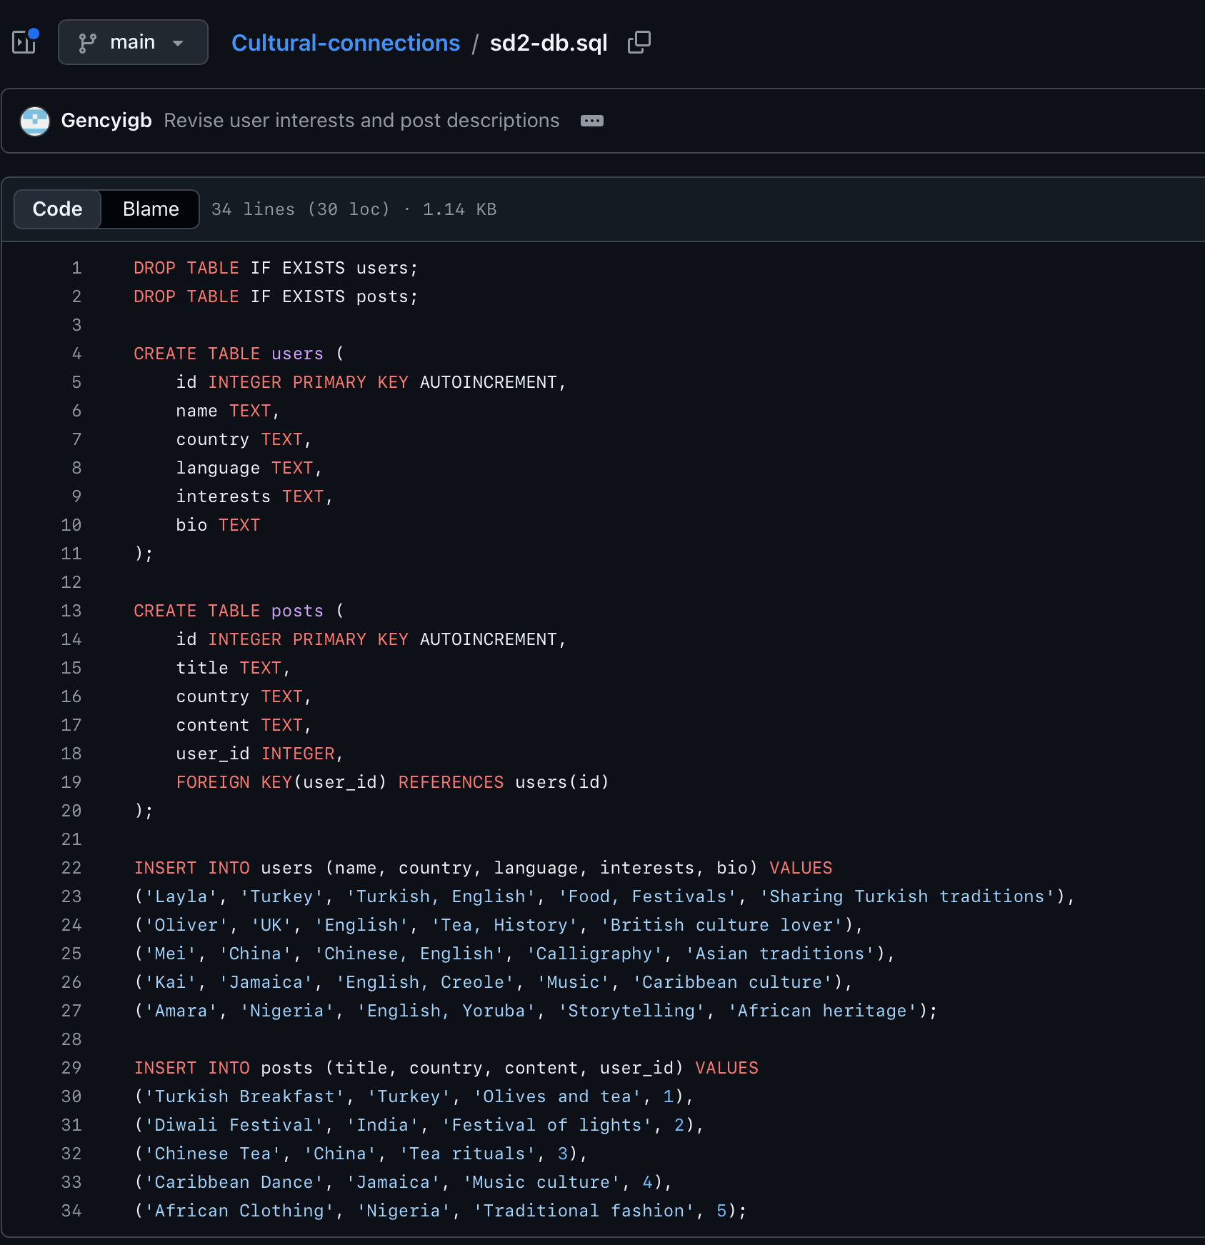
The User's table was designed to store key information about each user within the Cultural Connections platform. It includes fields such as name, country, language, interests, and a short biography, allowing each user to represent their cultural background and personal interests. The table uses a unique ID as the primary key to ensure that each user can be identified individually. This structure supports the functionality of the application by enabling users to be displayed in a list and accessed through individual profile pages. Overall, the Users table provides a clear and organised way to manage user data and supports the cultural sharing aspect of the system.
Figure 1: SQL table structure for Users
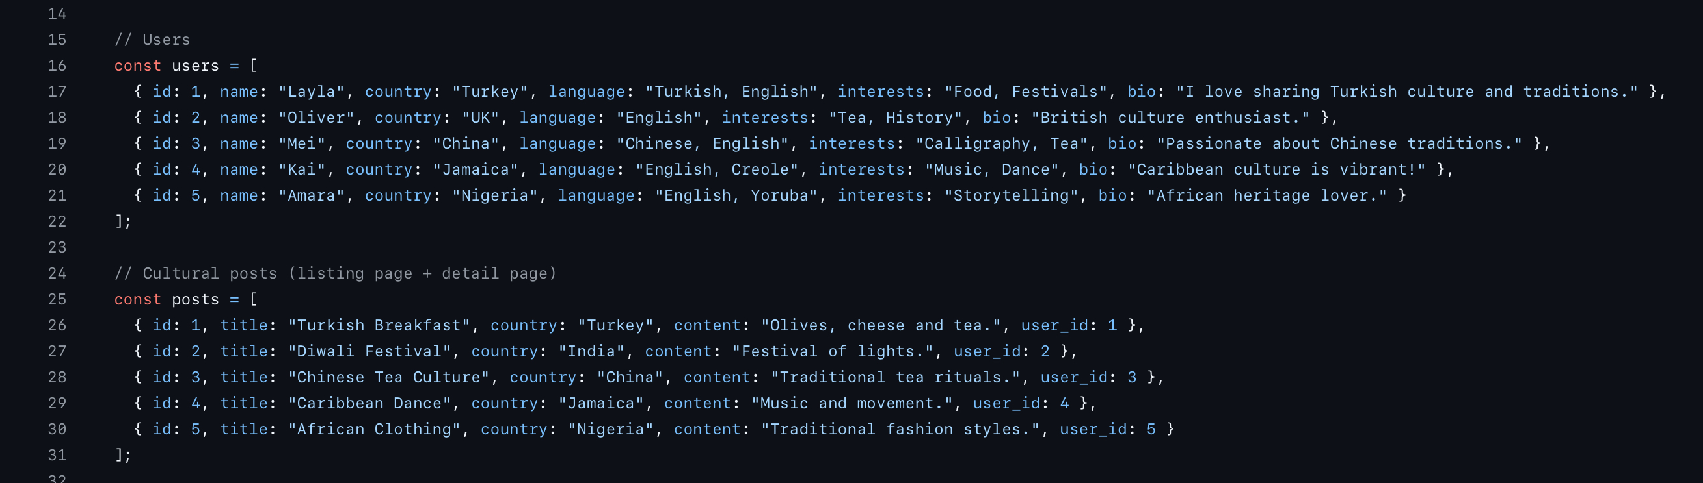
Figure 2: Sample user data defined in the application (app.js)
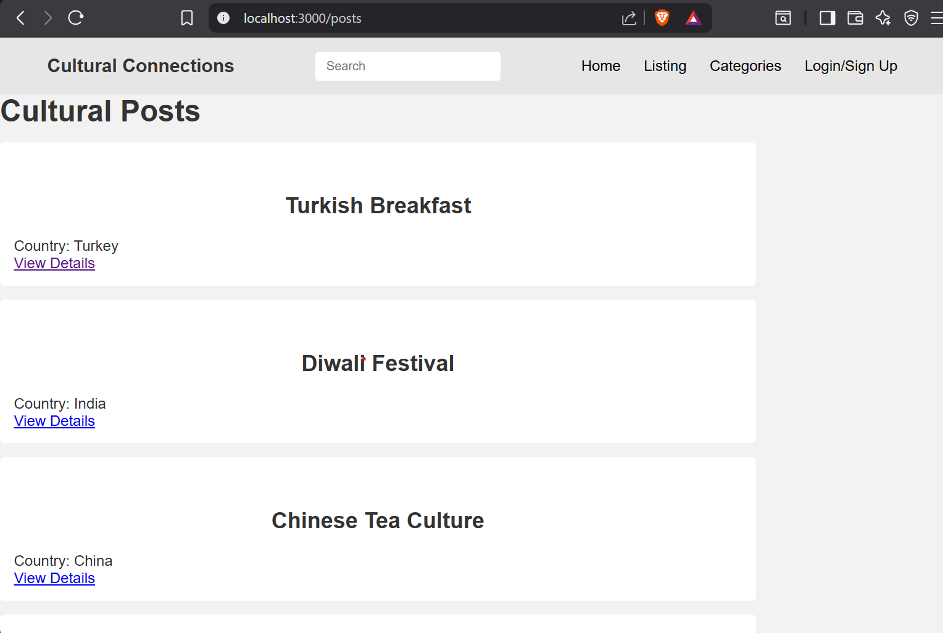
Figure 3: Users page displaying data
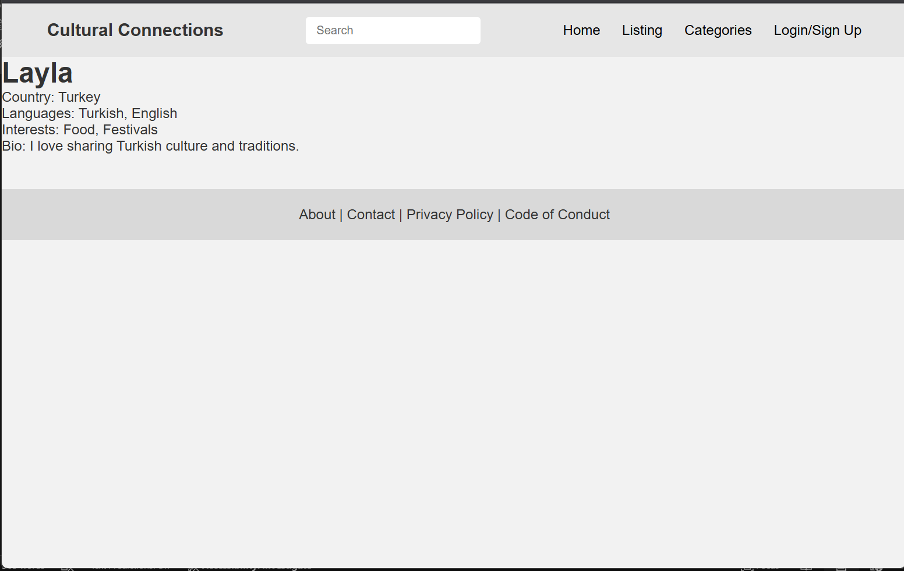
Figure 4: User profile page showing detailed information.

Task breakdown
Task | Description | Status | Member
Categories Page Template | Create Categories page with categories cards | Done | Lucie
CSS Styling | Styles created in styles.css | Done | All
Docker Testing | Verify pages work | Done | All
PDF File | Documentation of all work | Done | Lucie
User List Page | Create user list page | Done | Bahar
User Profile Page | User profile list created | Done | Bahar
Posts List Page | Posts list made | In progress | Aderinola
Post Detail Page | Post details created | In progress | Aderinola
Database Setup | SQL database created with data inputted | Done | All

GitHub repo Links
GitHub repo: https://github.com/Gencyigb/Cultural-connections
Github project board: https://github.com/users/Gencyigb/projects/1/views/1

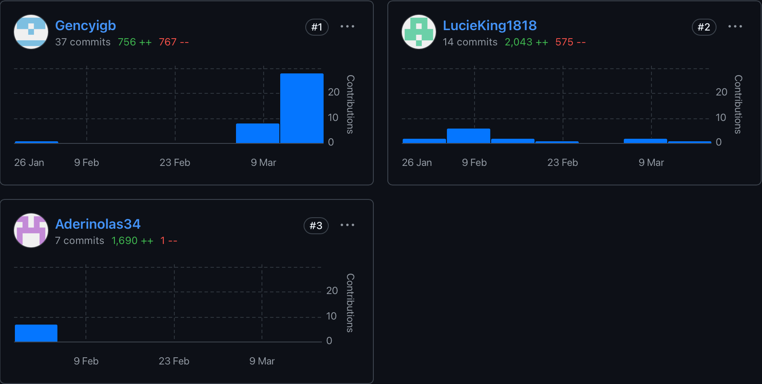
GitHub Metrics

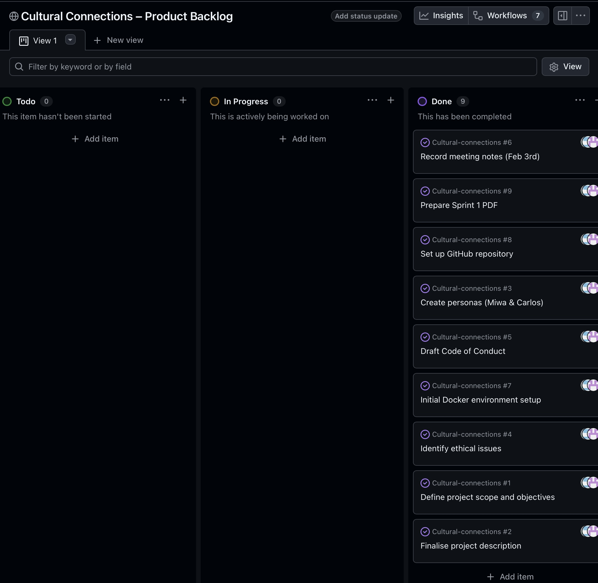
Kanban board screenshot (project backlog)

Meetings Record
Date: 10th march 2026
Attendees: Lucie, Bahar, Aderinola
Assigned work:
- Lucie: Categories page, PDF file documentation
- Bahar: Users page and User Profile Page
- Aderinola: Posts pages
I conducted this meeting via WhatsApp and allocated work to everyone. We used this time to discuss what is expected and that everyone was happy with the potential outcome of this sprint. Any miscommunications were cleared up in a constructive way so everyone understood the assignment.

